**MongoDB Image installation on docker**

**Step 1 :** Go to hub.docker.com and download docker for Windows system. Complete the setup in your system, to confirm the installation use the following command in cmd

*docker --version*

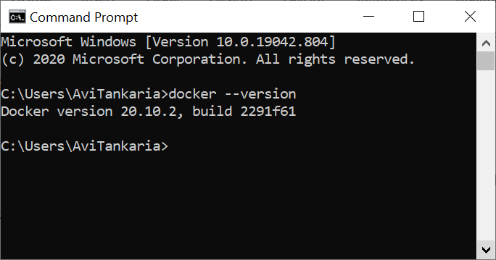

**Step 2:** Pull the MongoDB image in docker using the following command

*docker pull mongo*

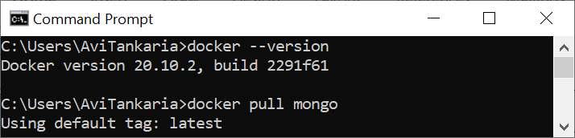

**Step 3: Start MongoDB image in the docker container using the below command**

docker run -p 27018:27017 --name mongodb -d mongo:latest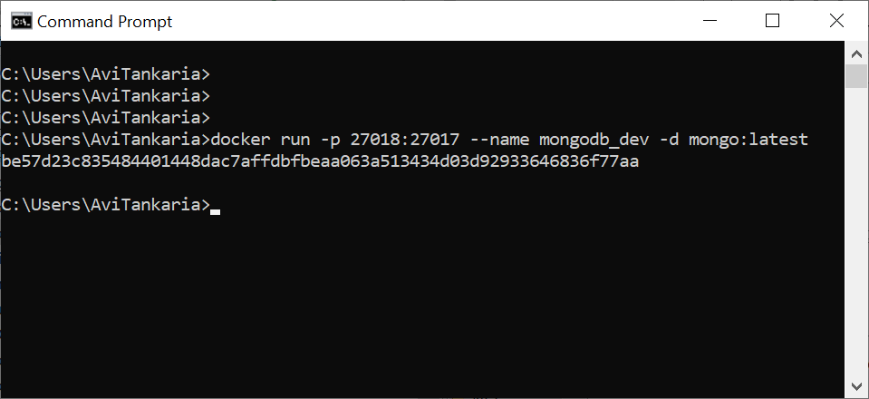

**Additional command:**

To check the number of containers running on docker

*docker container list*

**Step 4: To execute the docker MongoDB Shell**

*docker exec -it mongodb mongo and exit*(to exit from the shell)

**Step 5: Download MongoDB compass for windows**

**Enter the string in connection details and connect to the local cluster**

*mongodb://localhost:27018/*

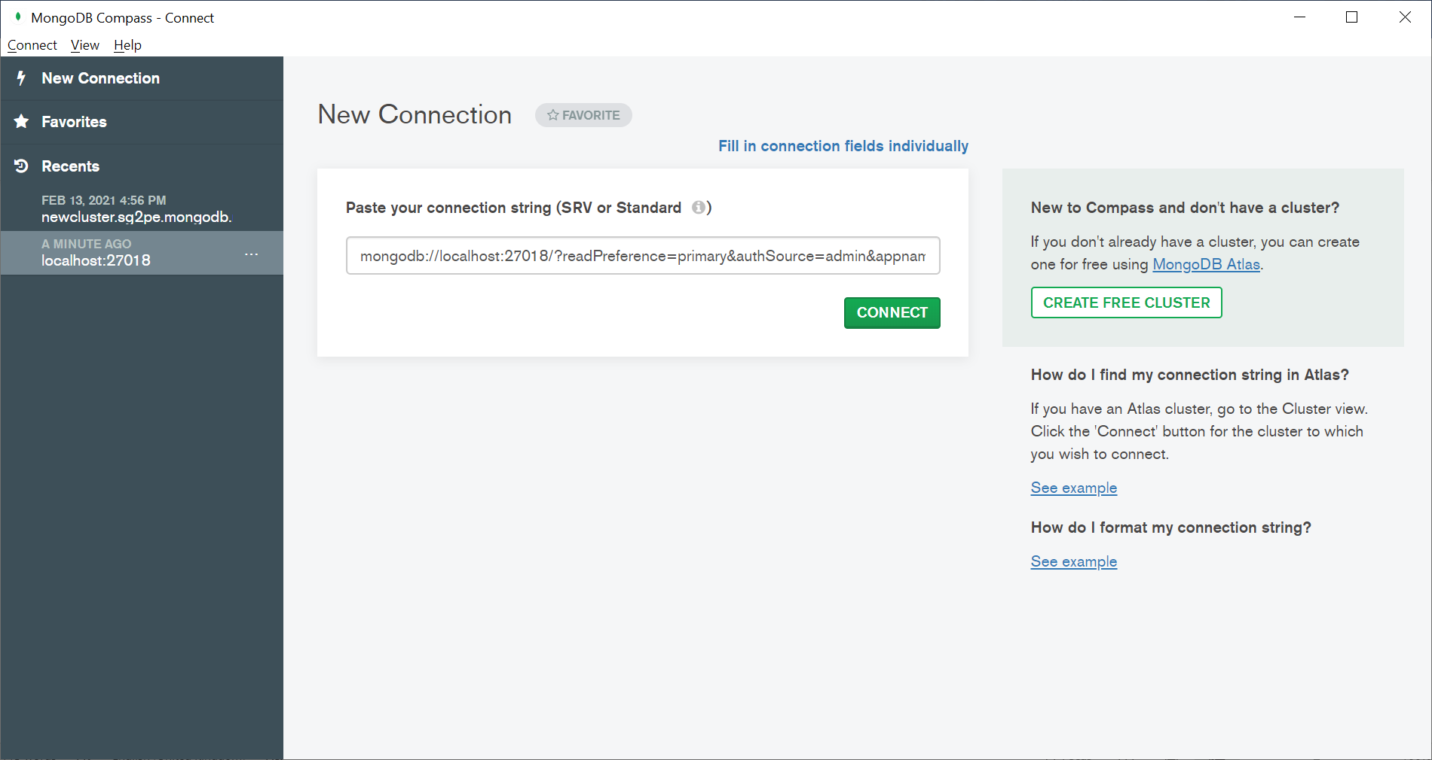

**Step 6: Create a database after the connection to local instance is established**

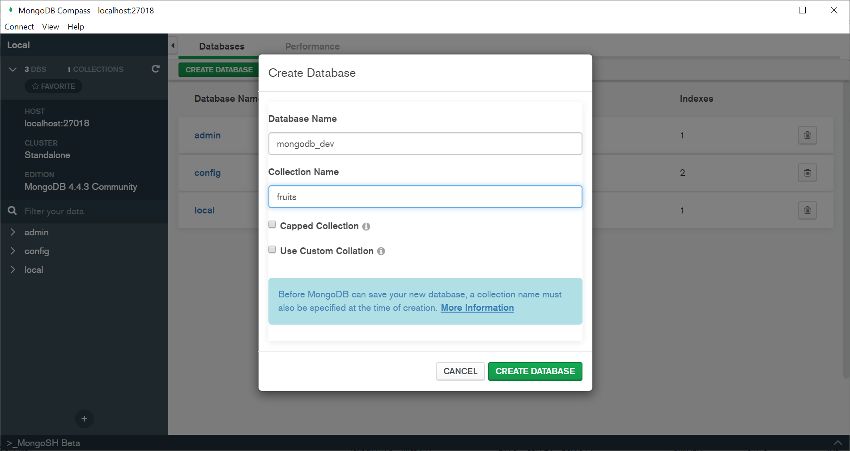

**Step 7: Run the below command on ACE console to install the ACE connecter on MongoDB**

cd %MQSI_WORKPATH%\node_modules

*npm install loopback-connector-mongodb –save*

**Step 8 : Paste the database.json file on the below location**

*Integration Server workpath\config\connectors\loopback*



**Step 9: Import “Mongo” Application from git and use the below attached payload to test the application**



*-----------------------------------------------------------------------------------------*

**For Ace to MongoDB connection please refer to the below link**

[**https://www.ibm.com/support/knowledgecenter/SSTTDS_11.0.0/com.ibm.ace.icp.eus.doc/certc_tutorial_accessmongodb.html**](https://www.ibm.com/support/knowledgecenter/SSTTDS_11.0.0/com.ibm.ace.icp.eus.doc/certc_tutorial_accessmongodb.html)

[**https://www.ibm.com/support/knowledgecenter/SSMKHH_10.0.0/com.ibm.etools.mft.doc/bz90805_.htm**](https://www.ibm.com/support/knowledgecenter/SSMKHH_10.0.0/com.ibm.etools.mft.doc/bz90805_.htm)